The Diffusion of Innovations

©2010 Richard P. Rumelt. This work is licensed under a Creative Commons Attribution NonCommercial 4.0 International License (CC BY-NC 4.0). You may copy, distribute, and adapt this material for non-commercial purposes, provided appropriate credit is given. Commercial use requires written permission from the author.

This technical note is a quick introduction to the use of diffusion models in forecasting. We use diffusion models in cases where an innovation diffuses through a population. In this note we focus on the simplest diffusion model: the logistic model. This model produces the familiar “S” curve in which a period of rapid acceleration is followed by deceleration and, finally, saturation.
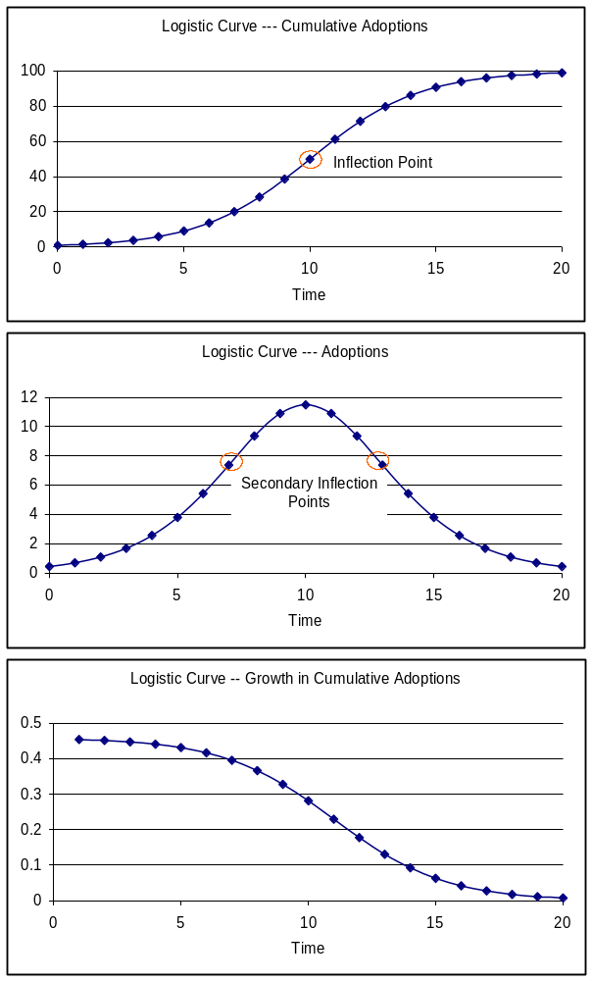
The graphs on the right show a logistic growth process. The basic idea is that some population adopts a new innovation over time. Eventually, all of the “target” population adopts. The top graph shows the cumulative, or total, number of adoptions rising from 1 to 100 in 20 years. The inflection point is the time at which the number of adoptions per year peaks (not the growth rate), falling thereafter. On the top graph, the inflection point appears as the time when the curve stops curving upward and starts curving back to the horizontal— towards saturation.
The middle graph shows the number of adoptions per year. If this were a product, the number of adoptions per year would be sales. Technically, it is the derivative of the top graph. There are secondary inflection points on this graph, where the adoption rate changes its curvature. These points correspond to the times of maximum curvature on the top graph.
Finally, the bottom graph shows the growth rate in cumulative adoptions over time. As can be seen, the growth rate falls from a high of about 46% to zero.

Logistic Growth Equations
To fully describe the logistic growth model it is necessary to use symbols and formula. Let the number of people (or companies, or other unit) adopting an innovation at time t be x(t), and let the total, or cumulative, number of adoptions by time t be X(t). The growth rate in cumulative adoptions is 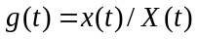. Logistic growth follows the law:
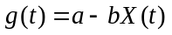
In , the parameter a is called the diffusion rate. The parameter b is the crowding effect, the amount by which growth slows due to each new adoption. More intuitively, if X = a/b, the growth rate is zero, so this ratio is the maximum, or equilibrium, or saturation, value of X. We will use the symbol
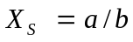
to denote this maximum value.
Given a, X_{S}, and the initial value X₀=X(0), the evolution of X over time follows the formula:
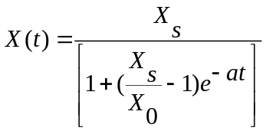.

Equation looks complicated. The growth rate of the number of adopters is complex, changing radically over time. However, there are two ways of looking at this process that reveal its basic inner simplicity. The first is , which tells us that the growth rate g in X decreases linearly with X. Note that the growth rate doesn’t decrease linearly with time—its time pattern is as shown on the third graph of page 1—it decreases linearly with X.

The second simple view is obtained by shifting from looking at X, the total number of adoptions, to instead look at U, the ratio of total adoptions to the remaining potential adopters. That is,
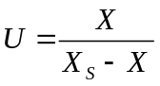.
Thus, when U = 1, exactly one-half of the potential adopters are using the innovation. The formula for U(t) is
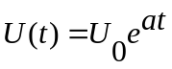.
where U₀ is simply U(0), the initial value of this ratio at time t = 0. The simplification is that U grows steadily at the exponential rate a. Put differently, 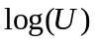grows linearly with time. If X_{S} were known (e.g., X_{S} = 100), then we could work with equation and estimate the diffusion parameter a directly as the growth rate of U. However, in cases where X_{S} is not known, both parameters must be estimated using equation .

Special Points
Given a logistic growth process defined by X_{s}, X₀, and a, the following formulae describe the key values:

m | 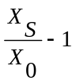 | Definition (used below)
 | 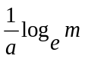 | Time of inflection
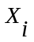 | 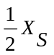 | Total adoptions at inflection point
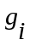 |  | Growth rate of total adoptions at inflection point
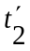 | 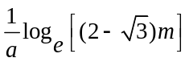 | Time of lower secondary inflection point.
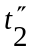 | 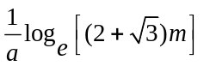 | Time of upper secondary inflection point
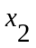 | 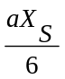 | Adoption rate at secondary inflection points (both)

Example 1⎯Known Saturation Point
Suppose we have the observations of the share of market taken by a new technology shown in Exhibit 1. Suppose further that we believe that this new technology will eventually take over the entire market. In other words, we believe that 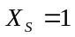, so the saturation market level does not have to be estimated.

Exhibit 1
Year | 1996 | 1997 | 1998 | 1999 | 2000
Market Share = X | 0.25 | 0.3 | 0.38 | 0.43 | 0.49

To fit a logistic curve to this data we first convert the observations from X to U, using : U = X/(1-X). We know from that if this is a logistic process, then U should grow exponentially at the constant rate a.

Exhibit 2
Year | 1996 | 1997 | 1998 | 1999 | 2000
Market Share = X | 0.25 | 0.3 | 0.38 | 0.43 | 0.49
U | 0.333 | 0.429 | 0.613 | 0.754 | 0.961
Growth in U |  | 0.286 | 0.430 | 0.231 | 0.274
As can be seen in Exhibit 2, the value of U does not grow at a constant rate—the year-to-year growth rate jumps around. To get an estimate of the future growth rate we could average up these growth rates, but there is a better way. The Excel function LOGEST, when applied to the data-array U, will produce a least-squares regression estimate of the growth rate of U. To be precise, LOGEST takes as inputs the observed values of U, and the years, and provides a least-squares fit to the function 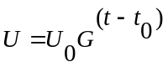. Doing this, the fitted value of G is 1.3077. Now, to predict future values of U, we extrapolate: the last observation is 0.961—multiply it by 1.3077 to get by 1.3077 over and over again—the regression says that U has, on average, grown by 30.77% each year.

If we actually wanted an estimate of the continuous growth rate in the logistic formula, we could use the relationship 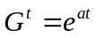, which tells us that a = log_{e}(1.3077) = 0.268. (Continuous growth rates are smaller than their year-to-year equivalents because they imply continuous compounding.)
Given the forecast of U, we re-convert it to market share using the relationship X = U/(1+U). The result is shown in Exhibit 2.
The forecast provided by the logistic curve shows market share climbing to 0.83 by 2006. The inflection point of a logistic curve is always at X_{s}/2, which is just 0.5 in this case. By assuming a logistic process and also assuming that the technology will spread to the whole market, we are forcing the inflection point to be at 50% share. Logistic processes always have the inflection point at one-half of the saturation value.
Exhibit 3
Year | Market Share | U | Regression fit of exponential growth in U
1996 | 0.25 | 0.33 | 0.337
1997 | 0.30 | 0.43 | 0.441
1998 | 0.38 | 0.61 | 0.576
1999 | 0.43 | 0.75 | 0.753
2000 | 0.49 | 0.96 | 0.985
 | Forecast |  | Extrapolation
2001 | 0.56 |  | 1.288
2002 | 0.63 |  | 1.685
2003 | 0.69 |  | 2.203
2004 | 0.74 |  | 2.881
2005 | 0.79 |  | 3.767
2006 | 0.83 |  | 4.927

Example 2—Unknown Saturation Level

Estimating logistic growth when the saturation level is not known is quite difficult, especially early in the growth process. Nevertheless, the following example shows a basic simple approach to this problem.
Exhibit 4 shows the number of Internet hosts (IP addresses that have been assigned a name). The data are collected by Network Wizards every six months (www.isc.org/ds/).
The logistic process says that growth drops linearly as X increases. To estimate g(t) (the growth rate) we will simply take each pair of points and obtain a bi-annual growth rate. Thus, for example, X(1995) = 5846 and X(1995.5) = 8200. The estimated growth rate in this interval is 8200/5846-1 = .403 = 40.3%.
Exhibit 4
Year | Internet Hosts | Growth Rate | Estimated Mid-Point Hosts
Jan-95 | 5846
Jul-95 | 8200 | 40.27% | 6924
Jan-96 | 14252 | 73.80% | 10810
Jul-96 | 16729 | 17.38% | 15441
Jan-97 | 21819 | 30.43% | 19105
Jul-97 | 26053 | 19.41% | 23842
Jan-98 | 29670 | 13.88% | 27803
Jul-98 | 36739 | 23.83% | 33016
Jan-99 | 43230 | 17.67% | 39853
Jul-99 | 56218 | 30.04% | 49298
Jan-00 | 72328 | 28.66% | 63766
Jul-00 | 93048 | 28.65% | 82036
Jan-01 | 109574 | 17.76% | 100973
Jul-01 | 125888 | 14.89% | 117448
Jan-02 | 147344 | 17.04% | 136194
This growth rate shouldn’t be matched to either the beginning or ending value, but instead to the value in the “middle” of the period. Because X(t) is growing, the value of X(t) at the time midpoint isn’t the average. To get the mid-time value we need to grow the value at the start of the period at the estimated growth rate for one-half of the period. Thus, for example, we estimate the mid-time value for March 1995 as
These calculations are carried out in Exhibit 4. The results are plotted in Exhibit 5.
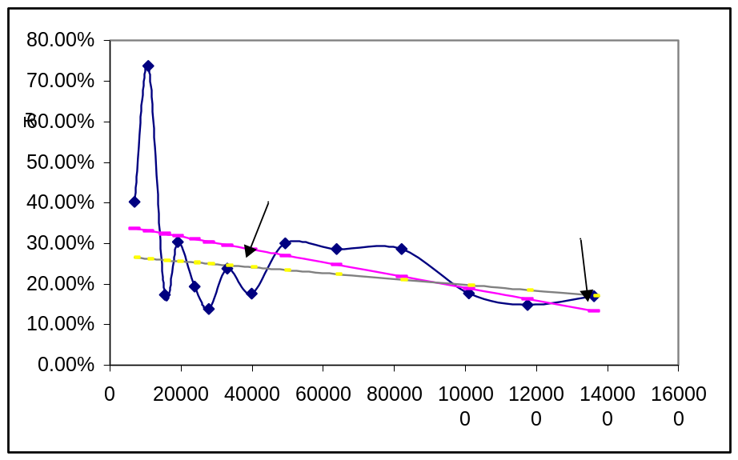

In Exhibit 5 we can clearly see the growth rate declining. The regression on all the data points (R2 = .18) has an intercept of a = 0.349 and a slope of -b = 1.6x10⁻⁶. The implied estimate of the saturation level is = 221,090.
We might not believe that growth is dropping that fast. One approach would be to leave out the outlier—the very high growth rate in the second half of 1995. Doing this gives an estimate of the intercept of a = 0.271 and a slope of –b = 7.2 x 10⁻⁷. These parameter estimates imply a saturation level of = 374,126. Somewhat larger.
Having an estimate of the saturation level makes forecasting easy. We can now easily calculate 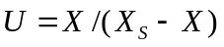 and grow that at 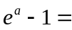31.1% per semi-year. Having extrapolated future values of U according to steady exponential growth, we convert back to hosts using the relationship 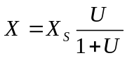. Doing this gives the forecast shown in Exhibit 6. If Internet Hosts evolve in this manner, the inflection point will be reached at the end of 2002. The inflection point is half-way to the saturation level. It is also the date at which the largest absolute number of new Hosts will be added. (The slope of the cumulative adoption curve is highest). From then on, fewer Hosts will be added each period.
It should be clear from this example that the graph shown in Exhibit 5 is the key to the forecast. Having such a graph allows us to forecast future growth rates. If we believe the linear assumption, then the forecast is a logistic process. If the growth is declining non-linearly, we have a more complex diffusion process. If the growth rate eventually goes to zero, there is a saturation level which will be reached at that time. If the growth rate simply declines, never touching zero, the process is not technically a diffusion process. Nevertheless, it can be forecast by simply forecasting the future pattern of the growth rate.

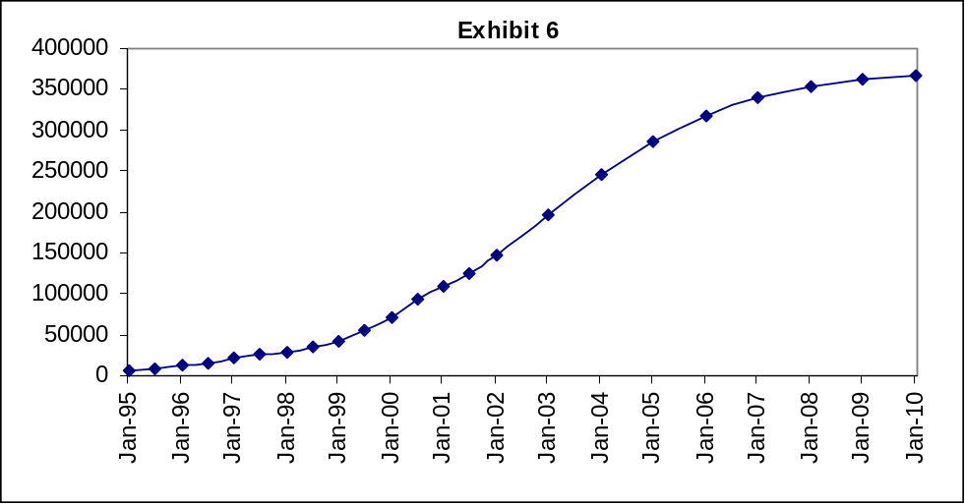

If we thought that the technology would take over only 60% of the market, we would simply take that as the target market and measure the share of the target. Thus, share would again rise from a low level to 100%. This is the simplification obtained by “knowing” the size of the target market—we can always then adjust cumulative adoptions to follow a share curve from 0 to 100%.

